Healthy Waterways Strategy

Stormwater Targets

Practitioners Note

July 2021

**Table of contents**

**Practitioners note 3**

**Purpose 3**

**The Healthy Waterways Strategy 4**

**EPA Urban stormwater management guidance 4**

**Healthy Waterways Strategy targets 4**

How were the targets derived? 4

**Estimating stormwater targets 7**

**Achieving the target on the ground 9**

Case Study 1 – Metropolitan Melbourne (Kororoit Creek Lower Sub-catchment) 12

**Appendix A 14**

**Practitioners note**

**Purpose**

This practitioners note:

Guides water and land development industry practitioners to identify stormwater targets for their location

Is designed for application within Melbourne Water’s operational area but can be applied across Victoria

Describes the background and scientific basis for the Healthy Waterway Strategy stormwater targets

Explains the relationship and alignment between the Healthy Waterway Strategy targets and EPA’s Urban stormwater management guidance document.

This note should be read with the [Healthy Waterways Strategy](https://www.melbournewater.com.au/about/strategies-and-reports/healthy-waterways-strategy) co-design documents that refer to specific catchments and sub-catchments.

Some of the key takeaway messages from this practitioner’s note include:

The HWS targets have been derived from a broad based and consultative process where community has clearly articulated their desire to protect Melbourne’s waterways into the future. The targets have been derived based on scientific evidence that supports that outcome

The targets in this note are applicable primarily to HWS ‘priority’ sub-catchments but they are also applicable to ‘other’ urban areas across Metropolitan Melbourne and regional Victoria

The stormwater targets have two elements: harvesting (that includes evapotranspiration) and infiltration

The targets can be expressed in terms of ML / impervious Ha /yr, highlighting imperviousness as the key driver of stormwater generation and waterway degradation. Targets can also be expressed in terms of percentage of runoff from impervious surfaces

Achieving the stormwater targets will require contributions from stakeholders operating at a range of spatial scales

Stakeholders need to be open to creating, supporting and contributing to opportunities that are beyond their project boundary. For example, allotment scale developers may contribute to precinct and regional scale opportunities. Collaboration between stakeholders to achieve this is therefore critical.

**The Healthy Waterways Strategy**

* The Healthy Waterways Strategy’s (HWS) vision is that “Healthy and valued waterways are integrated with the broader landscape, and enhance life and liveability”. (Healthy Waterways Strategy, 2018).

The HWS recognises that increased stormwater volume and intensity of peak flows is a result of urbanisation and a key threat to waterway health. The increased stormwater flows are also combined with pollutants and sediments from surrounding catchments, ultimately conveyed to Port Phillip Bay and Westernport.

Over a two-year co-design process, community knowledge and understanding of the scale and impact of stormwater on waterway health increased. Based on this, their strong preference was for the long term protection of Melbourne’s waterways. This co-design process and community preferences guided the development of the targets described below. While Melbourne Water manages Melbourne’s waterways, maintaining and improving waterway health is a shared responsibility across the water industry, State and Local Government, private enterprise and the community.

**EPA Urban stormwater management guidance**

The Victorian Environment Protection Authority’s *Urban stormwater management guidance* sets out urban stormwater performance objectives for priority and other areas. These performance objectives are expressed in terms of percentage reduction in mean annual impervious runoff volume.

Melbourne Water & EPA have worked together to prepare this note and develop a consistent framework, whereby the targets within the HWS and the *Urban stormwater management guidance* are aligned and reflect current scientific and industry knowledge.

**Healthy Waterways Strategy targets**

The HWS identifies stormwater harvesting and infiltration targets for 36 ‘Priority’ sub-catchments across Metropolitan Melbourne. Priority areas are designated areas which have high ecological values, where protection from the impacts of urbanisation is required to maintain the natural water cycle and protect the ecological health of those waterways. Failing to meet these targets is forecast to lead to significant declines in the health of most urban waterways across the region. Achieving the targets requires a contribution from both stormwater harvesting (plus evapotranspiration) that removes excess flows from surface water, and infiltration that maintains baseflows.

**How were the targets derived?**

The volume of stormwater generated within a sub-catchment is driven by impervious area and rainfall. The area of impervious surfaces (like roofs, roads and pavements) that are directly connected to waterways via pipes and drains is how the water industry measures the impact of stormwater on waterway health. This measure is referred to as ‘Directly Connected Imperviousness’ (DCI).

DCI is often expressed in terms of percentage of overall catchment area. Research has concluded that risks to waterway health increases significantly when DCI exceeds 2% of catchment area.

Not exceeding this threshold of 2% DCI is a key aspiration behind the quantification of stormwater harvesting and infiltration targets

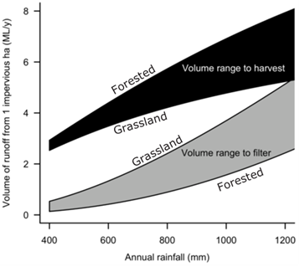

*Figure 1. Impervious runoff volumes to harvest and infiltrate to not exceed 2% DCI threshold across rainfall gradients. (*[*Walsh et al. 2012*](https://journals.plos.org/plosone/article?id=10.1371/journal.pone.0045814)*).*

It should be noted that the stormwater targets presented in the HWS have been derived based on gridded rainfall data which is at a higher resolution than the Model for Urban Stormwater Improvement Conceptualisation (MUSIC) modelling templates used by practitioners (discussed further below). The targets in this document have been brought in line with the modelling methods in the Melbourne Water MUSIC Guidelines 2018 to ensure they are applicable by industry practitioners.

Figure 1 shows the volume of stormwater runoff that needs to be harvested and infiltrated per Ha of impervious surface (as a function of rainfall) to achieve low levels of DCI across rainfall gradients. The width of the curve reflects a range of possible catchment characteristics. That is, where the original catchment was grassland (upper bound for infiltration / lower bound for harvesting) through to forested (lower bound for infiltration / upper bound for harvesting).

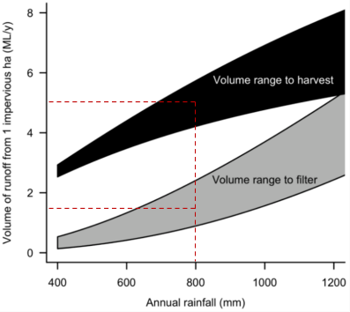

*Figure 2. Example harvesting and infiltration targets per impervious Ha for an 800mm rainfall catchment*

This relationship is the basis for the HWS targets that are expressed in terms of megalitre per hectare of impervious surface (or ML/Ha). For example, taking the centre of each band, in a sub-catchment with 800mm of rainfall a year, each additional hectare of impervious area will require harvesting at approximately 4.7 ML/year and infiltration at approximately 1.8 ML/year in order to not exceed the 2% DCI threshold.

In the HWS these targets are expressed for each priority area. For example, for the Merri Creek Upper sub-catchment the targets for stormwater harvesting and infiltration are *4.5 ML/y/ha of new impervious area and 1.1 ML/y/ha of new impervious area respectively. This equates to about 21.4 GL/y and 5.2 GL/y respectively at full development to the urban growth boundary*. To link the HWS targets and the performance objectives within the EPA’s *Urban Stormwater Management Guidance*, the HWS targets can also be expressed as a percentage of the impervious runoff generated in the catchment.

When expressed in percentages, the **stormwater harvesting targets** in the HWS and EPA guidance are equivalent. This target reflects criticality of flow reduction in protecting waterways and the experience of the water industry in planning and implementing stormwater harvesting schemes. This maturity brings with it an expectation that harvesting is implementable, and able to contribute to our targets. In ‘other (or non-priority) areas’ the targets are defined as being 40% of the target in priority areas. This is aimed at improving management in these areas and recognising that protecting waterways even in modified areas remains important.

Conversely, there is a difference between the **infiltration targets** in the HWS and EPA documents. Melbourne Water and the EPA have agreed upon the adoption of the minimum infiltration target curve in Figure 1 for the given rainfall in this practitioner’s note. That is, the infiltration target is to be read from the bottom of the ‘volume range to filter’ in Figure 1 above for priority areas. This is in recognition of the relative infancy of infiltration technologies, the need for clear industry guidance and the relatively limited application of infiltration assets in the development context currently. It is also recognised that a degree of infiltration may be achieved indirectly, e.g. through irrigation, leaking water mains and ageing drainage infrastructure.

**Estimating stormwater targets**

Practitioners that are estimating harvesting and infiltration targets for new impervious areas within HWS priority areas, will use one of six MUSIC modelling templates that have been prepared by Melbourne Water to support the identification of stormwater targets. Each template represents a different geography and rainfall ‘band’ across Metropolitan Melbourne. Figure 3 below shows:

* The HWS harvesting and infiltration targets for priority areas
* The EPA guidance targets for other areas
* The geographical range and average rainfall for each rainfall band
* The runoff per year for 1 Ha of impervious surface based on the specified average rainfall
* Harvesting and infiltration targets within that band both in terms of ML/Ha of impervious surface and percentage of impervious runoff harvested and infiltrated.

The appropriate MUSIC model can then be used to identify and model harvesting and infiltration measures to meet the targets for that location. [MUSIC Guidelines](https://www.melbournewater.com.au/sites/default/files/2018-03/Music-tool-guidelines.pdf) can provide further technical guidance for practitioners. While [Storm](https://storm.melbournewater.com.au/) is used in some circumstances to quantify *pollutant* load reductions as per the *Best Practice Environmental Management (BPEM)* and *Urban stormwater management guidance*, MUSIC is considered the most appropriate tool for this practitioners note.

Note that practitioners should refer to the Figure 1 curves to ensure they are not exceeding the maximum amounts for harvesting and infiltration. This avoids any negative impact from over-harvesting or over-infiltration.

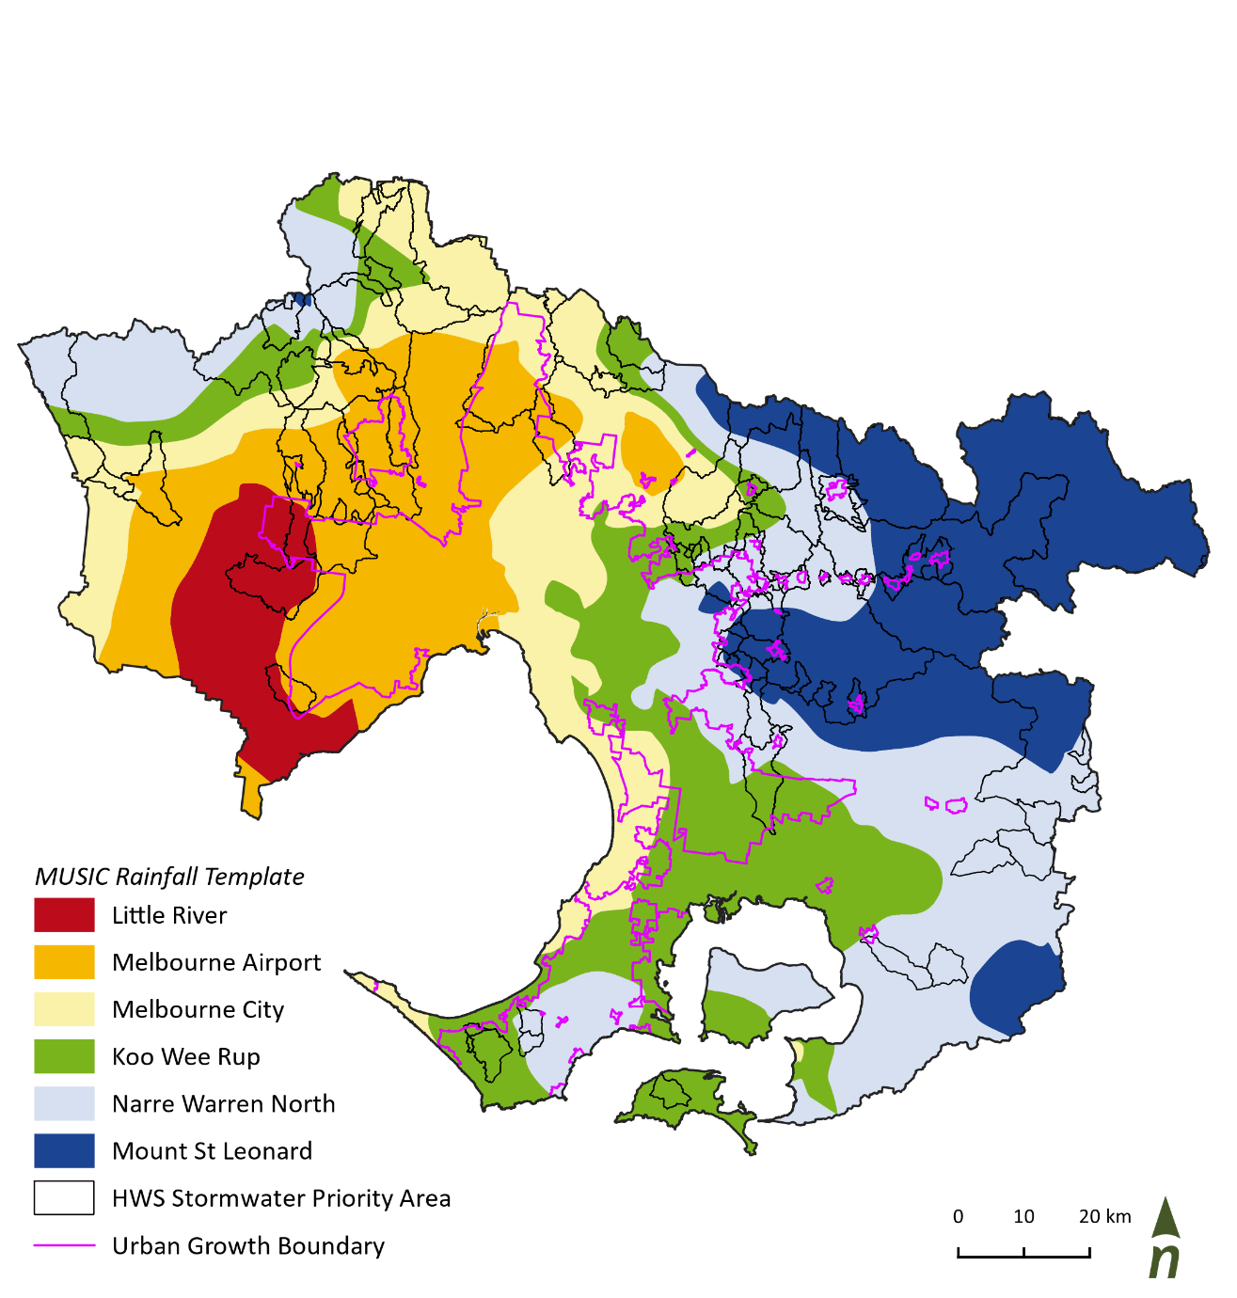

*Table showing MUSIC templates and corresponding harvesting and infiltration targets in stormwater priority and other areas in Metropolitan MelbourneFigure 3. MUSIC templates location, annual rainfall, and the urban growth boundary for Metropolitan Melbourne[1][2],[3],[4]*

**Achieving the target on the ground**

The HWS targets are a response to the community’s desire to restore and protect the condition of Melbourne’s waterways for future generations. Achieving these targets will require contributions from a range of stakeholders working across a range of spatial scales.

When developing in greenfield areas, stormwater volume reduction initiatives can typically be implemented at three scales (see Figure 4):

1. The allotment, street or development scale
2. The precinct scale
3. The regional or catchment scale.

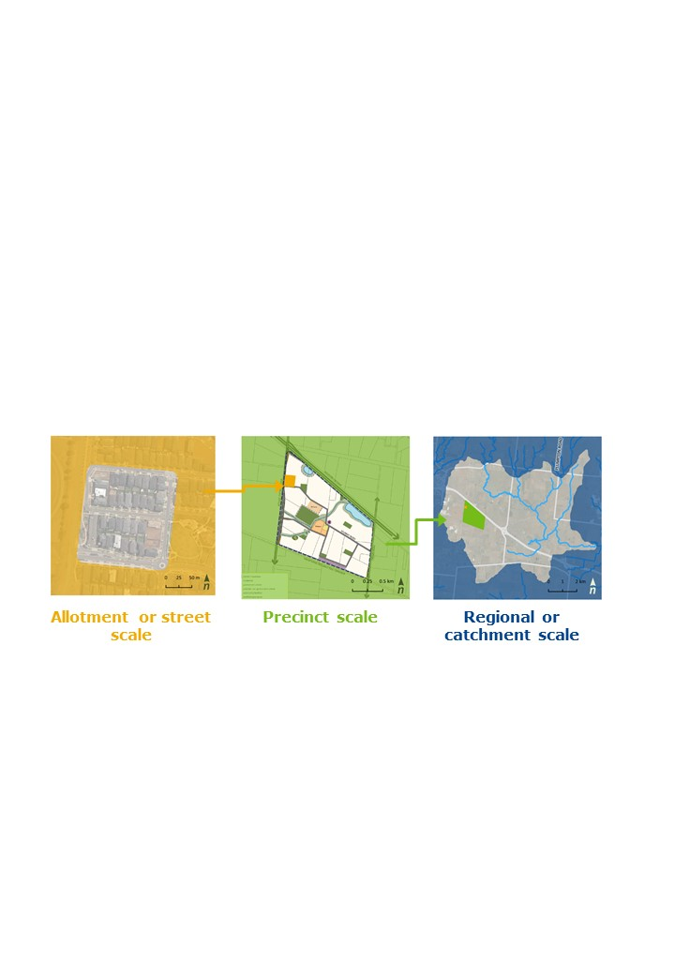

*Figure 4*. *Scales at which stormwater harvesting and infiltration opportunities are typically implemented*

Descriptions of each of these scales is provided in Table 1 below with examples of typical interventions at that scale. In considering scale, it’s important that the proposed targets need to be met upstream of the receiving waterway.

The land development industry in collaboration with water authorities, implement stormwater management and potable water conservation measures (like wetlands and rainwater tanks respectively) as part of drainage schemes and development-scale IWM Plans. Councils and water authorities also assist with the planning, design and funding of stormwater harvesting schemes.

While initiatives like rainwater tanks and wetlands represent an important contribution to infiltration and harvesting targets, they are unlikely to be sufficient in isolation to meet the HWS stormwater targets. Meeting the targets therefore likely requires interventions across a range of scales.

Table 1. Potential contributions to the HWS target at each scale

| Scale | Description | Typical interventions (examples) |
| --- | --- | --- |
| Allotment / street scale | Typically a smaller residential, commercial or industrial development.  Relies on landscape design to enable infiltration in the streetscape  Assumed to have little to no public open space and limited potential for stormwater irrigation. | * Lot scale rainwater tanks (‘leaky tanks’) * Lot scale raingardens * Street scale infiltration including passive irrigation for street trees |
| Precinct scale | A larger greenfield development or area covered by a precinct structure plan (PSP)  Include features like community facilities, active open space and passive space for relaxation.  May include a natural or (proposed) constructed waterway, stormwater treatment wetland or headwater stream  May also include commercial areas and one or more schools | Allotment / street scale interventions plus   * Stormwater harvesting for the irrigation of open space * Leaky wetlands for infiltration * Infiltration trenches in open space / garden beds * Large roof rainwater harvesting |
| Regional / catchment scale | An area defined more by regional than development or precinct boundaries  Would include a number of precincts that would incorporate a number of open spaces and treatment wetlands  Likely to include minor and potentially major waterways. | A stormwater network, collecting outflows from treatment wetlands for conveyance to meet a large demand (e.g. water for an irrigation district).  Plus precinct and allotment scale interventions as required |

Figure 5 illustrates the potential percentage contribution at each scale of intervention, recognising the constraints and opportunities within each context. It suggests that while allotment / street scale interventions deliver a valuable contribution, precinct and regional interventions are required. Where those interventions occur is also important with precinct and regional interventions needing to occur prior to stormwater reaching the receiving waterway. For example, distributed treatment and harvesting assets will be preferable to end of line schemes.

Options identified at the precinct and regional scale present opportunities that a range of stakeholders across scales can contribute to in order to meet the target in that location.

For example, land developers implement allotment / street scale interventions (e.g. rainwater tanks plumbed internally, raingardens, permeable pavements etc). However, if a precinct or regional scale opportunity has been identified beyond the development boundary, the developer may be required to contribute to the delivery of that opportunity. This could be via a financial contribution based on an impervious hectare rate.

This may be a similar process to that employed by Melbourne Water in applying their Development Service Schemes (DSS) whereby BPEM stormwater quality targets are met by catchment scale assets (like stormwater treatment wetlands), that are funded by developers contributing flows to that catchment.

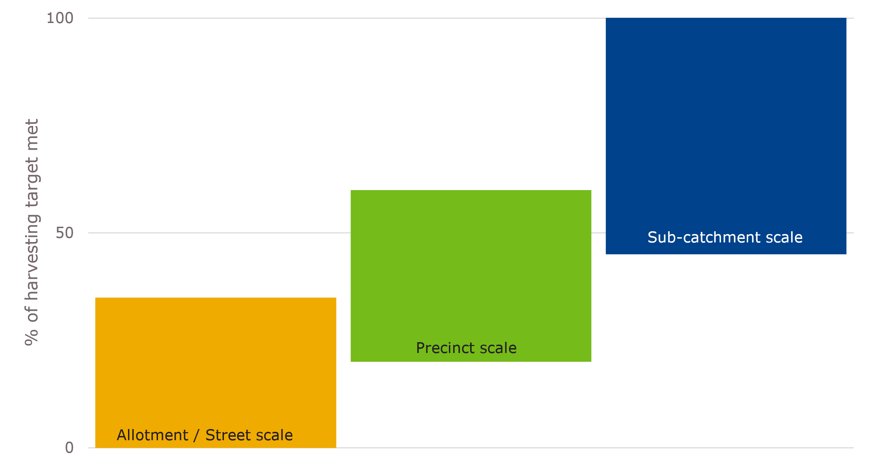

Regional / catchment scale

*Targets met prior to stormwater entering the waterway*

*Figure 5*. *Potential contribution of each scale of intervention in meeting the HWS targets for priority areas*

**Case Study 1 – Metropolitan Melbourne (Kororoit Creek Lower Sub-catchment)**

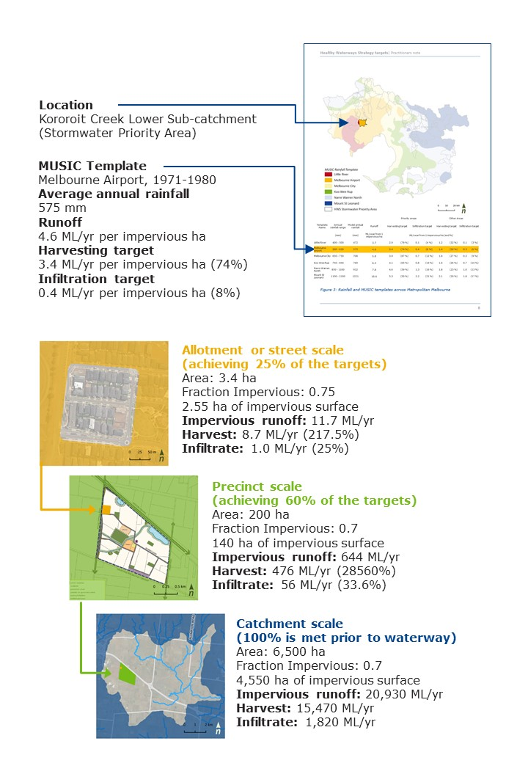

The case study illustrates how to determine targets. The example shown corresponds to an allotment or street scale but is applicable across multiple scales to allow flexibility for achieving the targets.

Working through the targets for a 3.4 Ha allotment or street scale example below:

* 3.4 Ha of developable area × 0.75 (impervious fraction) =2.55 impervious Ha
* Harvesting: 2.55 Impervious Ha x 3.4 ML/yr of runoff per impervious Ha = a harvesting target of 8.67 ML/yr
* Infiltration: 2.55 Impervious Ha x 0.4 ML/yr of runoff per impervious Ha = an infiltration target of 1.02 ML/yr.

The targets can also be determined using percentage of impervious runoff harvested and infiltrated as below:

* Read the percentage of runoff from each Ha of impervious surface to be harvested and infiltrated.
* Multiply Mean Annual Runoff by the harvesting and infiltration percentages to reach the target in ML/Ha of impervious surface/year:
  + Harvesting: 4.6 ML/ yr per impervious Ha x 0.74 = 3.4 ML/Ha of impervious surface/yr
  + Infiltration: 4.6 ML/yr per impervious Ha x 0.08 = 0.4 ML/Ha of impervious surface/yr
* Multiply this rate by the number of impervious hectares within the development to determine the ML/year to be harvested and infiltrated.
  + Harvesting: 3.4 ML/Ha of impervious surface/yr x 2.55 impervious Ha = 8.67 ML/yr
  + Infiltration: 0.4 ML/Ha of impervious surface/yr . 2.55 impervious Ha = 1.02 ML/yr.

Note that as per the MUSIC Guidelines, 3.4 Ha of developable area of a standard allotment size incorporating standard density lot sizes of 300 m2 – 600m2 would have a typical value of 0.75 (impervious fraction = 75%).

**Appendix A**

To support the application of the EPA’s stormwater targets across Victoria, the following table can be used by practitioners who are working outside the rainfall bands outlined in Figure 3 of the main document. The table:

* Includes 100mm interval rainfall bands and runoff from 1 Ha of impervious surfaces in an average rainfall year
* EPA priority area stormwater harvesting targets that are equivalent to the HWS stormwater harvesting targets
* EPA priority area infiltration targets that are equivalent to reading off the bottom of the ‘Walsh curve’ shown in Figure 1 of the main document
* EPA stormwater harvesting targets for other areas that are 40% of the target for priority areas.
* EPA infiltration targets for other areas that are 80% of the target for priority areas

The steps in using the table are:

* Locate the appropriate rainfall band for the given location to the nearest 100mm
* Note the Mean Annual Runoff from each Ha of impervious surface
* Read the percentage of runoff from each Ha of impervious surface to be harvested and infiltrated for priority and other areas
* Multiply Mean Annual Runoff by the harvesting and infiltration percentages to reach the target in ML/Ha of impervious surface/year
* Multiply this rate by the number of impervious hectares within the development to determine the ML/year to be harvested and infiltrated.

Practitioners outside Melbourne Water’s operating area should refer to their council or water authority to confirm their applicable rainfall band. If this information is unavailable, practitioners can refer to the Bureau of Meteorology average annual rainfall map for Victoria.

Note that practitioners should refer to the Figure 1 curves to ensure they are not exceeding the maximum amounts for harvesting and infiltration. This avoids any negative impact from over-harvesting or over-infiltration. For the very low rainfall bands, where the infiltration objective is 0%, and the curve is unclear, up to 5% would be acceptable.

|  |  |  |  |  |  |
| --- | --- | --- | --- | --- | --- |
| **Rainfall band (average annual rainfall) (mm/year)** | **Mean Annual Impervious Runoff (runoff from 1 impervious ha) (ML/year)** | **Priority areas** | | **Other areas** | |
| **Targets are expressed as a % reduction from Mean Annual Impervious Runoff** | | | |
| **Harvest / evapotranspire** | **Infiltrate / filter** | **Harvest / evapotranspire** | **Infiltrate / filter** |
| **200** | 1.4 | 93 % | 0 % | 37 % | 0 % |
| **300** | 2.2 | 88 % | 0 % | 35 % | 0 % |
| **400** | 3.1 | 83 % | 0 % | 33 % | 0 % |
| **500** | 3.9 | 77 % | 5 % | 31 % | 4 % |
| **600** | 4.8 | 72 % | 9 % | 29 % | 7 % |
| **700** | 5.7 | 68 % | 11 % | 27 % | 9 % |
| **800** | 6.6 | 64 % | 14 % | 26 % | 11 % |
| **900** | 7.5 | 60 % | 16 % | 24 % | 13 % |
| **1000** | 8.5 | 56 % | 18 % | 22 % | 14 % |
| **1100** | 9.4 | 53 % | 19 % | 21 % | 15 % |
| **1200** | 10.4 | 50 % | 21 % | 20 % | 17 % |
| **1300** | 11.3 | 48 % | 22 % | 19 % | 18 % |
| **1400** | 12.3 | 46 % | 23 % | 18 % | 18 % |
| **1500** | 13.3 | 44 % | 25 % | 18 % | 20 % |
| **1600** | 14.2 | 42 % | 26 % | 17 % | 21 % |
| **1700** | 15.2 | 40 % | 27 % | 16 % | 22 % |
| **1800** | 16.2 | 38 % | 28 % | 15 % | 22 % |

*Figure A. Quantitative performance objectives for urban stormwater across Victoria*

1. Priority areas harvesting target provides direct alignment between the HWS, EPA *Urban stormwater management guidance* and UDIA *EnviroDevelopment Technical Standards*.
2. Priority areas infiltration targets correspond with the bottom of the infiltration curve in Figure 1.
3. Other areas harvesting targets are defined as being 40% of the target in priority areas.
4. Other areas infiltration target corresponds to 80% of the target in priority areas.